UFO-Sweden

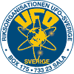

The organization UFO-Sweden (UFO-Sverige) was grounded in 1970. They have investigated reports of UFOs from all over Sweden. They have only one way to get money so that they can afford their research of UFOs. So the one and only income beside their own inputs of money come from their magazine “UFO Aktuellt” that you can bye from their website.
UFO-Sweden has not committed itself to any particular theory on the origin of the UFO phenomena.
UFO-Sweden has during the 1990s managed to become a clearer profile as a serious organisation, which people, the mass media and the authorities can ask with confidence.
UFO-Sweden has several local representatives in the whole country, two of them in lies here in Stockholm, but only one observation since 1952, where a picture has been taken, has been reported to UFO-Sweden from the Stockholm area.

Reported UFOs with pictures to UFO-Sweden:

Skillingaryd 6/5 1971 – The most famous Swedish picture of a UFO
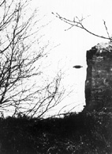
Sätila 18/9 1971

Falun 9/1, 10/1, 15/1 1985
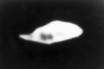
When Dala-demokratens photographer Rune Österlund was on his way against Falun in his car, he sight on a remarkable items just 100 metre over the way. On the front of the item sat two intensively shining searchlight. But in spite of the fact that Österlund had his equipment with him could he not stay to take a picture – The traffic was to heavy. Next evening, the 10 january, he had bigger luck. Some days later, the 15 of January, a colleague of Österlund managed to take a picture fully in color of a bright light. Västerbergslagens UFO-förening engaged them roughly in the magazine “vågen” and published a comprehensive report of the incident.
Martebo sep-okt 1986
Sundsvall 12/5 1991

Ekerö 15/1 1993
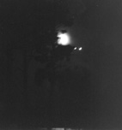
A flight attendant was able to take this photo of two strongly shining "stars" next to the moon. In the report to UFO-Sweden she writes: "I looked a long time, when these neither looked like airplanes or stars because of the strength of the lights. Suddenly the two lights moves extremely fast against-from-around each other." The woman went out barefoot in the snow in order to see better and takes several images. After some minutes the two lights went of in two different directions in a furious pace. UFO-Sweden’s investigation shows that no stars or planets can explain the observation. It strong light in middle is moon.

Other observations:
Mora 15/9 1952
Marskär 9/8 1956
Rättvik 17/11 1968
Härnösand och Östersund 20/6 1970
Sätila 18/9 1971
Sverige och Norge 1/1 1972 – Not a UFO, it was a rocketstage from the space shuttle Kosmos 453 that fell into the atmosphere.
Värnamo 21/3 1974
Hällefors 1977 – The person that took the photo has confessed that the picture was fake.
Falkenberg 15/8 1978 – Probably a bird of pray that was captured by the flash while its hunting.

