ROLLING  STONES | 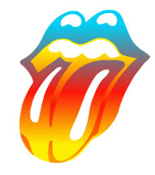

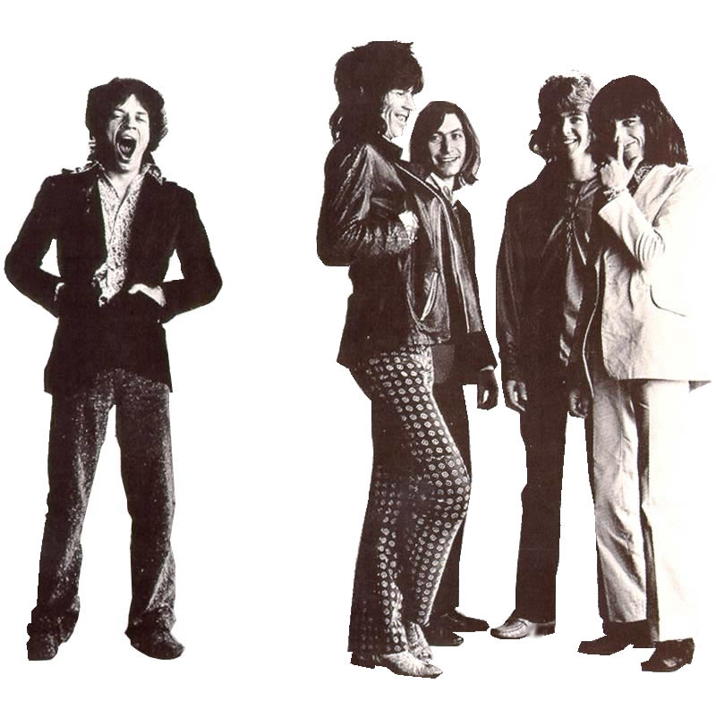

Skrivet av: Oskar Ossowicki, 8N

Table of Contents
Main text | ........................................ | 1-2
Summary | ........................................ | 2
Conclusion | ........................................ | 2
Sources | ........................................ | 2
Short Discography | ........................................ | 3

The Rolling Stones
When you think about the history of rock you can’t possibly ignore them or look around them, they’re without no hesitation, definitely the greatest and most important band of the musical history! They were pioneers and together they’ve played for more than 40 years, which make them very remarkable and outstanding. Of course! I’m talking about The Rolling Stones!
The Stones were formed by five young and rebellious Britishmen in 1962. The original five members were Keith Richards, multi-instrumentalist Brian Jones (mostly on the Guitar), Bill Wyman on the bass, Charlie Watts on the drums and last but definitely not the least, Mick Jagger on vocals. Mick Jagger is the front figure of The Rolling Stones, probably he's the one to thank for bringing them to the top. The group's big breakthrough was in 1963 when they had several songs high up on the top lists. On July 12, 1962 at the Marquee they had their first performanced show. They're repertoire was in the early years mostly songs which were composed by others, for example their first five singles and the bulk of their first two albums were composed by the rock-and-roll titans of the 1950's. The first all-original album with songs only composed by the members of The Rolling Stones were “Aftermath”(1966) where Brian Jones, the bands prettiest face and best instrumentalist, played on marimba, dulcimer, sitar, and assorted keyboards. Since Brian were not very good in composition he soon got marginalized. He declined in creativity and influence, and was becoming a drug addicted and depressive man. This caused he were fired by the band on June 9,1969, and soon he was found dead in his swimming pool on July 3 the same year. At a concert in London's Hyde Park, Mick Jagger read an excerpt from a poem by Shelley and released thousands of butterflies over the park. Mick Taylor replaced Brian Jones.
More tragedy was about to strike the group when the Stones gave a free "thank-you America" concert at California's Altmont Speedway. A young black fan, Merideth Hunter, was stabbed to death by members of the Hell's Angels motor cycle gang. The Stones had hired the gang - on the advice of the Grateful Dead - as security for the event. The murder was captured on film by the Maysles brothers in their documentary "Gimmie Shelter". As a result of public outcry, "Sympathy for the Devil" was dropped from the set-list for the next six years. The band had actually been playing "Under My Thumb" when the murder occurred.
As the Stones were becoming bigger they formed their own record label Rolling Stones Records in 1970. Under this time they released "Sticky Fingers" which became the #1 in 1971. With this album the design "lips and lolling tongue logo" by Andy Warhol were introduced to the fans.
Later on Mick Taylor left the group and were replaced by the guitarist Ron Wood after many auditions with top session men. Officially Wood joined the Stones in 1976.
In March, 1977, Keith Richards and his common-law wife, Anita Pallenberg, were arrested in Canada for possession of heroin. The arrest jeopardized the future of the Stones - but Richards was given a suspended sentence and subsequently kicked his bad habit in 1978.
Some of the Stones's classics, "Start Me Up" and "Waiting On a Friend" came with the album "Tattoo You"(1981) and was the #1 for nine weeks. After the album a tour for it produced the live album "Still Life" and a concert film - Hal Ashby's "Let's Spend the Night Together".
In the beginning of the 80s the group was in a low rate period. However, the two next releases, "Undercover" and "Dirty Work", featured one top 20 hit. After this the group didn't meet up in the studio again until three years later. During this off-time Mick Jagger made two
1.
solo albums, one of them, "She's the Boss", was a huge success. Also Keith Richards made a solo album during this time, "Talk is Cheap"(1988). Jagger and Richards were longtime writing partners, and now Richards made a single aiming on Jagger, it was "You Don't Move Me".
First in 1989 the Stones reconvened and made an album together again. The album was "Steel Wheels", which's tour made their fifth live album, capturing the spirit of the Rolling Stones which many had believed was actually gone.
Wyman retired in 1992 and was replaced on tour by Daryl Jones, formerly a bassist for Miles Davis and Sting and the first non-british member of the group.
The Rolling Stones's latest release is "Forty Licks"(2002) which consists by 36 of their best sons and also by 4 songs recorded in 2002.
And as far as i know the world history's greatest rock n' roll band, the Rolling Stones, still go strong, even today!

Summary
In 1962 the British rock-and-roll group the Rolling Stones were formed. They were about to become one of the greatest musical legends in history. The front figures of the band was Mick Jagger and Keith Richards. They've been holding the group together for over 40 years. In the early days they played mostly songs composed by others but in 1966 they're first all-original album “Aftermath” was released. The Stones have made amazingly many tours and have released an almost unthinkable amount of albums.

Conclusion
As I've written hundreds of times already the Stones is by no doubt the greatest group, which have been holding together for the longest time and made a lot of hits through the years, this is not only what I've read about but also what I fully agree with. As I listen to their most popular songs from the early years to the later performances I tend to like the early songs better, I think it's mostly because as the time goes by the music also get influences from the time which goes by. Since this is what I think I'd say, the Stones were actually the best in the early and the mid years but got worse as they got influenced by more modern music, but they're still the greatest!

Sources
http://the-rolling-stones.idoneos.com/
http://www.amazon.com/exec/obidos/ts/artist-biography/48687/
http://members.chello.nl/f.dejonge/albums.htm
http://www.scaruffi.com/vol1/stones.html
http://search.eb.com/britishinvasion/Rolling_Stones.html

2.

Short Discography
Here is some short facts about some of the albums that was mentioned or at least should have been mentioned in the text.

Aftermath 1966  Mother's Little Helper  Stupid Girl  Lady Jane  Under My Thumb  Doncha Bother Me  Goin' Home  Flight 505  High and Dry  Out of Time  It's Not Easy  I Am Waiting  Take it or Leave It  Think  What To Do | 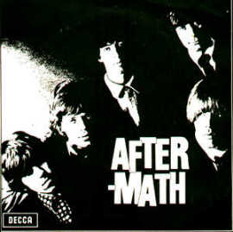

Tattoo You 1981  Start Me Up  Hang Fire  Slave  Little T & A  Black Limousine  Neighbours  Worried About You  Tops  Heaven  No Use in Crying  Waiting On a Friend | Undercover 1983  Undercover of the Night  She Was Hot  Tie You Up  Wanna Hold You  Feel On Baby  Too Much Blood  Pretty Beat Up  Too Tough  All the Way Down  It Must Be Hell | Dirty Work 1986  One Hit (to the Body)  Fight  Harlem Shuffle  Hold Back  Too Rude  Winning Ugly  Back To Zero  Dirty Work  Had It With You  Sleep Tonight
Forty Licks 2002
Disk One  01. Street Fighting Man  02. Gimme Shelter  03. (I Can't Get No) Satisfaction  04. The Last Time  05. Jumpin Jack Flash  06. You Can't Always Get What You Want  07. 19th Nervous Breakdown  08. Under My Thumb  09. Not Fade Away  10. Have You Seen Your Mother, Baby  11. Sympathy For The Devil  12. Mother's Little Helper  13. She's a Rainbow  14. Get Off My Cloud  15. Wild Horses  16. Ruby Tuesday  17. Paint It Black  18. Honky Tonk Women  19. It's All Over Now  20. Let's Spend The Night Together | Disk Two  01. Start Me Up  02. Brown Sugar  03. Miss You  04. Beast Of Burden  05. Don't Stop  06. Happy  07. Angie  08. You Got Me Rocking  09. Shattered  10. Fool To Cry  11. Love Is Strong  12. Mixed Emotions  13. Keys To Your Love  14. Anybody Seen My Baby?  15. Stealing My Heart  16. Tumbling Dice  17. Undercover of the Night  18. Emotional Rescue  19. Only Rock 'n Roll (But I Like It)  20. Losing My Touch 3.

