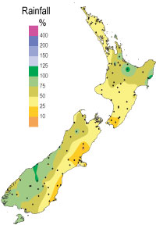
New Zealand’s Climate

The temperature on New Zealand is varied, the highest temperature was + 42° and the lowest was – 22°. The ordinary temperature is about + 14 ° to + 18° or + 5° to + 11°.

The ordinaries weathers are sunshine or rain. But it’s not always sun or rain; it’s snow and cyclones as well. So if you’re going to do outdoor activities, you must be prepared on many different weathers.

On one year, there is over 2000 hours with sun, and it rains between 640 mm. to 2000 mm.

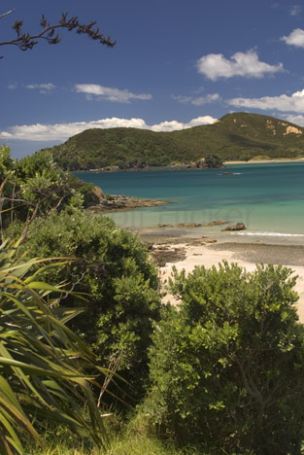
New Zealand’s spring months are from September to November, the summer months are from December to February, the autumn months are from March to May and the winter months is from June to August. So you could say that it is differences at the months, if you compare with Sweden.

