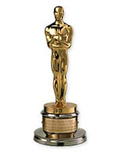
New Zealand’s famous people

About Peter Jackson:
He was the first one to direct three movies at the same time. These three movies is “The Ring trilogy”. And he’s got an Oscar for the best manuscript.

About Russell Crowe:
He’s a very famous actor and he’s been in many movies; two of them (that is very famous) are “Gladiator” and “Cinderella man”. Some other movies are “A beautiful mind”, “L.A. Confidential”, “Master And Commander” and so on.

About James Cook:
He isn’t from New Zealand, but his name is related to New Zealand because he was the one to make a survey of New Zealand.

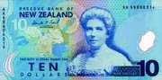
About Kate Sheppard:
She was midwifery, but now she’s dead. Kate’s face is on the ten dollars note for New Zealand, because she was the first women who speaked for other women’s rights, she was also the one to give women’s the right to vote.

About Sir Peter Blake:
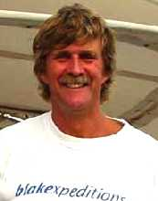
Peter Blake was a sportsman who liked to sail. But once, year 1995, pirates attacked him. But he survived. Under the years, he’s been in many sailing contests. Peter and his team won many competitions and took many silver trophy’s as well. But 2001 he was attacked by pirates again. And this time he wasn’t so lucky, because they killed him. Before he died, he was the world’s most famous sailor. As a result of his successes he received a knighthood from the Queen of England in 1991; Sir Peter Blake.

