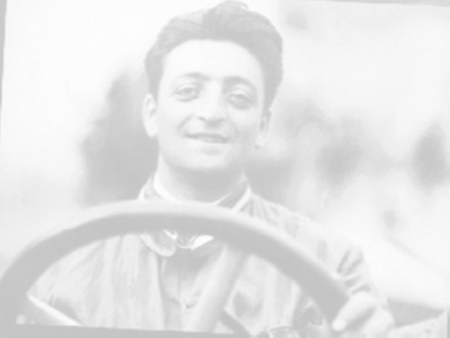
Enzo Ferrari

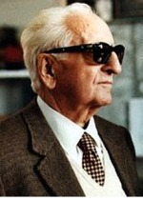
Enzo Ferrari was born the 18 February 1898 in Modena north of Italy.
He started his career as a test driver and as a racing driver. Then in 1920 he started to work for Alfa Romeo and he advanced to chief for the racing team.
In 1929 was the racing team Scuderia Ferrari founded by Enzo Ferrari.
The team became gradually a part of Alfa Romeos racing team. During the Second World War in 1940 was the factory that built machines for ball bearing production bombed.

But in 1946 it was rebuilt, after which they started to produce the first Ferrari.
The company became a limited company in 1960, and in 1969 became FIAT owner of the half. Today the own 90 percent of the share capital, and the Ferrari family 10 percent.

Ferraris popular trademark, with the rising horse comes from a decoration on a
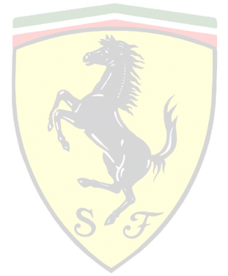
airplane from Italy’s most famous flying ace from the first world war. Francesco Barrara was his name and he fell in the war, but Enzo Ferrari met his parents 1923. They wanted to have their sons symbol to decorate Ferraris cars. The horse was already black but the yellow background was chosen by Enzo Ferrari because it was Modenas colour.

Today Ferrari has about 1700 employees, and there are 1350 that works on the factories in Maranello and Modena, and 350 are employed with the Racing team. With the factory in Maranello there is a 3 kilometers long test track, Fiorano. Ferrari has also the bigger racing track in Mugello, north of Florens.

All from the beginning has Ferrari designed and built fantastic sport and racing cars in Italy. Legendary names like 250 California, F40, F50, and 288 GTO. Enzo gave some cars names from Dino, Enzo Ferraris son. Dino died about 20 years after he was born because of an illness.
One of Ferraris biggest cars was Ferrari Enzo. The Ferrari Enzo was built when Enzo died the 14 August in 1988.

Lars Åsén 9d

